DESTINATION: Practice / Training ride for the longer Victoria, BC bike hike in late May. Round-trip between Gas Works Park and Matthews Beach Park on the Burke Gilman bike trail. This is a rail road grade paved bicycle trail. This portion of the trail follows Lake Union, past UW, and then Lake Washington.

DEPART Meet at Gasworks Park parking lot at 9:30 a.m. Saturday, May 12, 2018. Bicyclists will engage in a brief safety orientation, perform a basic
safety check of his/her bike, organize into smaller groups based experience, and leave the parking lot to
begin the ride at around 10 am.
LEADERSHIP
ADULT: Trent Siegel, 206-909-8438 (cell) (need another adult to come along)
SCOUT:

PROGRAM This is an approximately 2-hour local bike outing. See the attached Bike Safety check list. Limited tools will be available for on-site repairs during the ride. Scouts should have a spare tube and patch kit in case of a flat tire.
ROUTE The route will be the North Central portion of the Burke Gilman trail between Gas Works Park and Matthews Beach. Total distance is 14 miles roundtrip. The trail is paved, flat, and encounters automobiles only at trail crossings. Cyclists are required to follow all rules of the road. Scouts are to ride single file to the right and remain in assigned groups. Do not leave another scout riding alone. Always pass on the left of other trail users. Be courteous when passing others. Announce when you are approaching and call “On your left!” so you do not have someone suddenly ride or step into your path and cause an accident. You must remain aware of your surroundings at all times to avoid accidents. If you see another rider coming upon the group from behind and any of our scouts is not safely to the right, call “bike back” to warn our riders. Scouts and accompanying adults are required to wear helmets whenever riding. An approved adult, patrol leader, or designated scout will ride ahead and behind each group.
EQUIPMENT This is a 2 hour local bike trip. Scouts must have: 1) a bicycle in safe working order, 2) a properly fitting helmet, 3) a water bottle in a small day pack or on their bike, 4) weather appropriate clothing (including sun protection), 5) snacks and/or some pocket money to purchase a snack.
A properly fitted multi-speed bicycle will insure a more enjoyable ride. Also recommended is a spare tube to fit your bike and/or a patch kit. A compact bicycle tool kit is also an excellent thing to have, even if you are unfamiliar with all the tools. Another scout or adult will be able to use it in case of a breakdown.
Do not wear jeans or pants with thick seams in the seat area. Avoid cotton clothing as it absorbs moisture remains wet against the body. Wear short (if weather permits) and/or athletic pants/tights with close fitting ankles to keep the pant leg from getting caught in the chain of the bike. If pants with wider legs are worn, wear a pant strap or rubber band around the right pant leg to prevent the material from entangling with the chain. Cycling specific shorts/pants are padded to improve comfort while riding and are suggested if you have them.
FOOD Pack a snack that can be carried while cycling to eat on the route. Bananas, peanut butter sandwiches, granola bars, are all good options. Bring a water bottle with a top that can be popped open with your teeth while riding (screw caps should be avoided). We will stop at the Metropolitan Market Sand Point / Burke Gillman park on the way back for a snack break. If you want to buy something, bring some cash.

RETURN Scouts should arrive back at the Gas Works Park parking lot at 12 pm. Parents should plan to pick up scouts and bikes from there.

SIGN-UP Signed permission slips are due at the Gas Works Park parking lot the day of the trip on May 12th.

PERMISSION AND MEDICAL RELEASE FORM:

Scout ___________________________ has my permission to participate in the Burke Gilman bike outing, May 12, 2018 sponsored by Boy Scout Troop 166.

Contact phone number for any unexpected circumstance:
This phone contact must be available from departure at parking lot to return.

Youth Protection Training completion Date: _________________ Mandatory to or accompany Scouts.
Good for two years.

YES NO I’m available to accompany the Scouts on the outing.

I hereby give permission for any and all medical attention necessary to be administered to my child in the event of an accident, injury, sickness, etc., under the direction of the adults listed on this form or the adult leaders listed on the trip bulletin until such time as I may be contacted. This release is effective for the time during which my child is participating in a Troop 166 Boy Scout outing, including traveling to or from activities. I also hereby assume full responsibility for payment of any such treatment.

Parents’ or Guardians’ Names: __________________________________

Home Address: __________________________________

Home Phone: __________________________________

Work Phone: __________________________________

Health Insurance: __________________________________

Policy Number: __________________________________

Signature of Parent or Legal Guardian: _____________________________________

Date:________________________

Scoutmaster: Bill Montgomery Phone: (206)523-0072
Sponsor: Trent Siegel Phone: (206) 909-8438
Pre-Ride Bike Safety Inspection
- Check the tires for proper inflation (marked on the side of the tire).
- Check the tire treads for excessive wear or other damage, such as embedded glass or other objects.
- Check the brakes. Spin the wheels to check for rubbing and then apply the brakes to ensure they stop the bike smoothly and evenly.
- The brake levers should not contact the handlebars when fully applied. If the levers contact the grips, this is a sign the brake cables have stretched and need adjustment.
- Check the brake pads for excessive wear.
- Check the cables and housing to make sure there is no fraying or splitting.
- Check the wheel quick release levers to ensure they are secure and facing backwards.
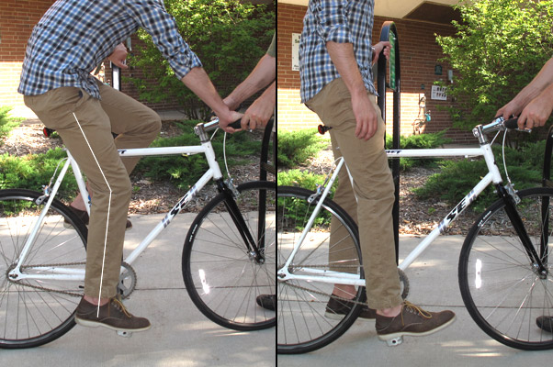
- With the front wheel between the legs, try to turn the handlebars. If the handlebar stem twists in the bicycle headset, the handlebar stem must be tightened.
- Check the height of the seat is properly adjusted for the rider. See image below.
- Check the seat post mount. Twist the seat to ensure the seat post binder is tight.
- Pedal and shift the gears through all cogs. Be sure the drive train is shifting properly.
- Check for any loose parts or other mechanical problems.
- Do a slow-speed ride and inspect bicycle, brakes, and shifting before you leave your driveway.

