DESTINATION Blake Island Marine State Park. The 476 acre island park is nestled between Bainbridge Island and Vashon Island and is only accessible via water. The park boasts 15 miles of hiking and biking trails, 1700 feet of shoreline, and stunning views.

More Information https://en.wikivoyage.org/wiki/Blake_Island
Map http://parks.state.wa.us/DocumentCenter/Home/View/1843

DEPART SPECIAL EARLY DEPARTURE - Meet directly at Sea Scout Dock – Lake Union 7:30am sharp. Sea Scout Dock is located 2223 N Northlake Way (Waterway 18), just a few blocks east of Gasworks Park. See map at end of this document.

LEADERSHIP SCOUTMASTER: Bill Montgomery, ADULT TRIP SPONSOR: Cliff Shettler
SCOUT: Mclean Thompson, SPL

PROGRAM We arrive at Blake Island around 10:00am. Our campsites will be on the North side of the island close to the dock and Tillicum Village. After setting up camp and eating lunch, the late morning and afternoon will be spent with Patrol Adventure Hikes, Free Time, “Wild Game”, Rank Advancement, then Cooking and Dinner. Saturday evening will have a campfire program. Sunday morning will be Breakfast, Games, Chapel, followed by loading the boat and then setting sail home around 1pm.
ROUTE Transportation provided by Captain Al Bruce and the Sea Scouts of the SSS Propeller
EQUIPMENT This trip is an overnight camping trip. Potable water is available. Pack in firewood. Scouts must be prepared for inclement weather. Patrols are required to bring sufficient tents, tarps and dining flys, etc. Troop 166 practices Leave No Trace – i.e. leave only footprints, take only pictures – so bring garbage bags, and plan carefully. Bring your 10+ essentials including extra clothing and rain gear for possible conditions, sun protection, towel, map and compass, water bottle, day pack, trail food, waterproof matches and fire starters, a pocketknife, first-aid kit, flashlight and batteries, overnight camping gear including a warm sleeping bag.
FOOD The patrols are responsible for preparing dinner on Saturday plus Breakfast on Sunday. Each patrol will invite an adult to join them. Provide your own trail food, and sack lunches for Saturday and Sunday unless your patrol makes other arrangements.
FEE $25.00 CASH covers transportation and permits. Provide an additional $8.00 CASH to your patrol (all adults, too) for food expenses. Scholarships are available. Contact Bill Montgomery at least 5 days prior to the outing.
RETURN Troop will arrive back at the Lake Union Sea Scout Dock around 3pm on Sunday, September 17th. Troop will call the phone tree as we steam on back.
SIGN-UP Don’t wait until our next Troop Meeting to sign up! Space is limited to 41 scouts and adults. Send me your permission slip and $25 to confirm your passage. Cliff Shettler, 7419 Woodlawn Ave NE, Seattle, WA 98115.

PERMISSION AND MEDICAL RELEASE FORM:

Scout has my permission to participate in the Blake Island outing, September 16 & 17, 2017 sponsored by Boy Scout Troop 166.

Contact phone number for any unexpected circumstance:
This phone contact must be available from departure at parking lot to return.

Youth Protection Training completion Date: _________________ Mandatory to drive or accompany Scouts.
Good for one year.

YES NO I’m available to accompany the Scouts on the outing.

I hereby give permission for any and all medical attention necessary to be administered to my child in the event of an accident, injury, sickness, etc., under the direction of the adults listed on this form or the adult leaders listed on the trip bulletin until such time as I may be contacted. This release is effective for the time during which my child is participating in a Troop 166 Boy Scout outing, including traveling to or from activities. I also hereby assume full responsibility for payment of any such treatment.

Parents’ or Guardians’ Names: __________________________________

Home Address: __________________________________

Home Phone: __________________________________

Work Phone: __________________________________

Health Insurance: __________________________________

Policy Number: __________________________________

Signature of Parent or Legal Guardian: _____________________________________

Date:________________________

Scoutmaster: Bill Montgomery Phone: (206) 523-0072
Adult Trip Sponsor: Cliff Shettler Phone: H (206) 525-0067 C (206) 471-5253

If Corliss Ave N extended down past Pacific St it would intersect N Northlake Way close to 2223 North Northlake Way (Waterway 18)
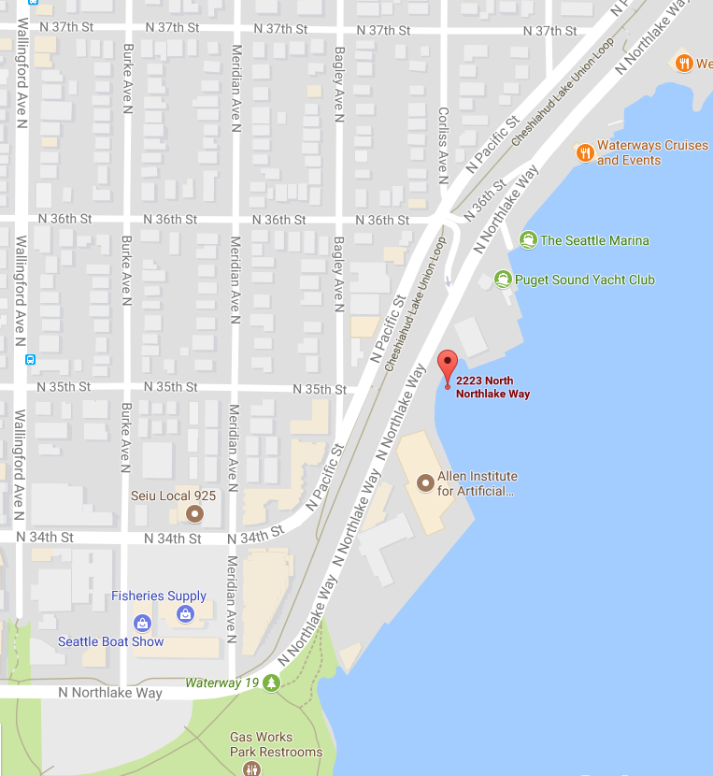

Find the little brown tag (center right) that says “Waterway 18”. This is 2223 North Northlake Way. Just to the right of the Waterway 18 tag is the Sea Scout dock jetting out into the water.

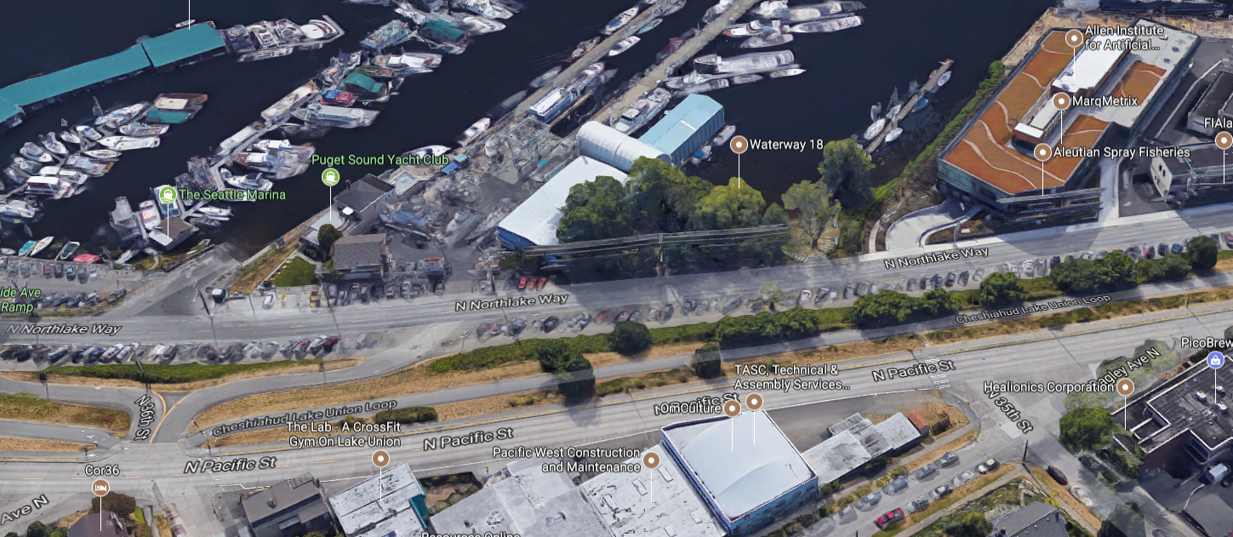

We will meet Saturday morning on the grass just outside the dock entrance

